

Department | FED
Subject | DSA-2
Academic Year | Ⅰ-Ⅲ Semester(2025-26)
Faculty Name | Ms. Mamatha
Student Name | Lankey Tejasri
Roll Number | 2520090017
Branch | CSIT
Course Outcome | 2
Case Study Topic: Student Database Indexing System using B-Tree and Segment Tree

Work Done Summary:
It was implemented to demonstrate efficient database indexing and range query processing using B-Tree and Segment Tree data structures. A Student Database Indexing System was developed to manage student records and perform analytical operations on marks data.

Implementation Details :

- Created Student Node class with fields: rollNumber, studentName, marks, left, right, and height.
- Implemented B-Tree insertion method to store student records in a balanced indexed structure.
- search( ) method retrieves student details efficiently using Roll Number indexing.
- updateMarks( ) method updates marks of existing student records in the database.
- delete( ) method removes duplicate or invalid student entries while maintaining proper tree structure.
- Segment Tree was implemented for efficient range query processing on student marks.
- rangeMaximum( ) method identifies the highest marks within a specified range of students.
- rangeSum( ) and averageMarks( ) methods calculate total and average marks for selected ranges.
- inorderTraversal( ) displays all student records in sorted order based on Roll Number.
- comparePerformance( ) analyzes efficiency between normal searching and indexed searching techniques.
- analyticsReport( ) generates performance reports such as topper details and average class performance.
- Main method demonstrated student insertion, searching, updating, deletion, range queries, analytics processing, and report generation.

Result : Screenshots/Output
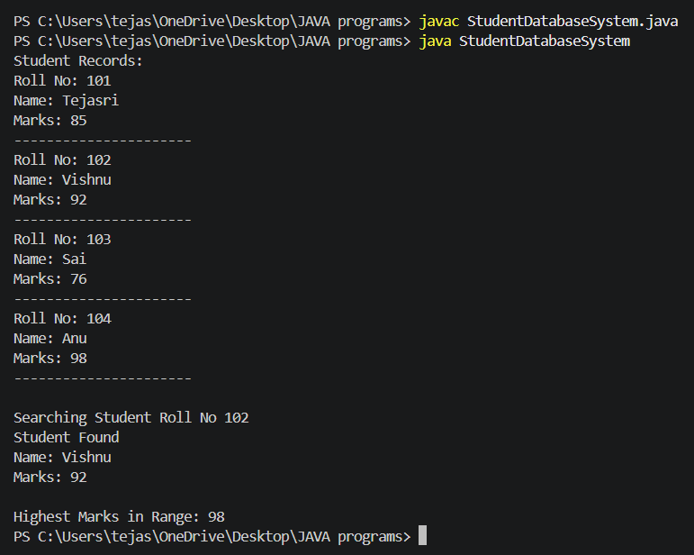
Time Complexity:
Time Complexity Analysis
- B-Tree Insert/Search/Delete: O(log n) (average case)
- Segment Tree Range Query Operations: O(log n)
- Segment Tree Construction: O(n)
- Student Record Traversal: O(n)
- Maximum Marks Query: O(log n)
- Compared to Array/List searching O(n), B-Tree indexing and Segment Tree operations provide faster searching and efficient analytical processing for large-scale student database management systems.
GitHub Link : https://github.com/tejasrilankey/DSA-CO-2
Student Signature | Faculty Signature

